**WEB ADMIN USER (SEED USER)**

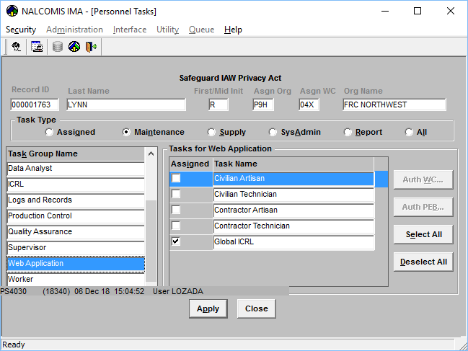

############################################

Type: cd /usr/share/ntcss-ldap

Type: ll ntcss-webadmin*

Type: **./ntcss-webadmin-useradd.sh**

Enrolling the Initial Web System Administrator

To add a Web Administration User Account:

After identifying the target user’s

CN (Common Access Card (CAC) Canonical Name)

and SN (NTCSS User Name):

Login to the NALC box using your System Administration account.

Switch user to root. At the prompt,

Type: **sudo su –**

Type: **/usr/share/ntcss-ldap/ntcss-webadmin-useradd.sh** **[ENTER]**

The following prompt appears:

Please enter your **CAC's CN**: **STEVE.EXAMPLE.NMN.12345678901** **[ENTER]**

The following prompt appears:

Please enter your **NTCSS User Name**: **EXAMPLE [ENTER]**

The script will display an informational message whether or not

the user is **successfully added**.

RESULTS:

dn: cn=LYNN.REBECCA.NMN.1231733511,ou=ADMIN,ou=NTCSS_WEB_ACCESS,o=optimized

sn: **rp8058**

cn: **LYNN.REBECCA**.NMN.1231733511

dn: cn=TUGGEY.DARREN.KYLE.1299581604,ou=ADMIN,ou=NTCSS_WEB_ACCESS,o=optimized

sn: **dt0191**

cn: **TUGGEY.DARREN.KYLE**.1299581604

dn: cn=HUCKINS.TRACEY.LOUISE.1465029796,ou=ADMIN,ou=NTCSS_WEB_ACCESS,o=optimiz

ed

sn: **th2828**

cn: **HUCKINS.TRACEY.LOUISE**.1465029796

############################################

# DELETE “WebAdmin” USER

############################################

Type: cd /usr/share/ntcss-ldap

Type: ll ntcss-webadmin*

Type: **./ntcss-webadmin-userdel.sh EXAMPLE**

############################################

# SEARCH “WebAdmin” USER

############################################

Type: cd /usr/share/ntcss-ldap

Type: ll ntcss-webadmin*

Type: **./ntcss-webadmin-usersearch.sh -a**

Options:

-a, --all Displays all users that are currently web admins

-c, --cn[=VALUE] Explicitly marks a user's CN (CAC Canonical Name)

-s, --sn[=VALUE] Explicitly marks a user's SN (NTCSS User Name)

-h, --help Display this help and exit

2600 Eltham Avenue, Suite 110 | Norfolk, VA 23513

757.222.1438 Office | 757.572.7147 Mobile| 757.204.4628 Fax [www.tqiinc.com](http://www.tqiinc.com)

Select name from sysobjects

Where name like ‘OOMA%’

GO